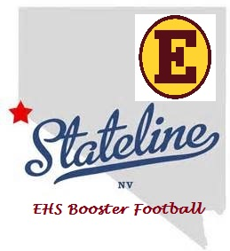
Estancia Football Booster Stateline Turnaround Bus Trip,
Saturday June 7, 2014
Buffalo Bill's
We will be boarding the bus at 6:30 am and leaving Estancia High School parking lot no later than 7:00 am. We will be stopping in Corona off Hwy 15 and Foothill at the Wal-Mart parking lot to pick up additional passengers. Arrive at Stateline by 11:00 am and return to Estancia High School 11:00 pm
Each passenger will receive a meal coupon and $10 free play money uploaded onto your player’s club card upon arrival to the casino.
ALL PASSENGERS MUST BE 21 AND HAVE AN ID,
IT’S MANDATORY
Price per Passenger: $40.00 is needed before June 2, 2014 please make checks payable to Estancia Sports Booster Club
Upon arrival to our destination 8 hours later is our departure time. You will need to be outside and inline 15 minutes prior to departure.
If you bring alcohol it must be in a plastic container or can…. Please call 714-697-0001 or email me at laxcell@gmail.com (LeeAnn) if you have any questions.
FUN, FUN ON THE RUN TO STATE LINE….

